**LAB # 1**

**AN OVERVIEW OF NETWORKING**

**OBJECTIVE**

Introduction of Network and Packet Tracer, Cisco IOS CLI, Basic Switch Configuration & Device Security.

**THEORY**

* **Computer networking**

Computer networking is the engineering discipline concerned with communication between computer systems or devices. Networking, routers, routing protocols, and networking over the public Internet have their specifications.

• A computer network can be two computers connected:



• A computer network can also consist of, and is usually made for, more than two computers:



* **Characteristics of a Computer Network**

The primary purpose of a computer network is to share resources:

• You may have a computer with a CD writer or a backup system but the other computer doesn’t have it; In this case, you can burn CDs or make backups on a computer that has one of these but using data from a computer that doesn’t have a CD writer or a backup system.

• you can connect a printer (or a scanner, or a fax machine) to one computer and let other computers of the network print (or scan, or fax) to that printer (or scanner, or fax machine)

• You can place a CD with pictures on one computer and let other computers access those pictures

• You can create files and store them in one computer, then access those files from the other computer(s) connected to it.

* Introduction Packet Tracer

Packet Tracer is a self-paced, visual, interactive teaching and learning tool developed by Cisco. Lab Activities are an important part of networking education. However, lab equipment can be a scarce Resource. Packet Tracer provides a visual simulation of equipment and network processes to offset the challenge of limited equipment. Students can spend as much time as they like completing standard lab. Exercises through Packet Tracer, and have the option to work from home. Although Packet Tracer is not a substitute for real equipment, it allows students to practice using a command-line interface. This “e-doing” capability is a fundamental component of learning how to configure routers and switches from the command line.

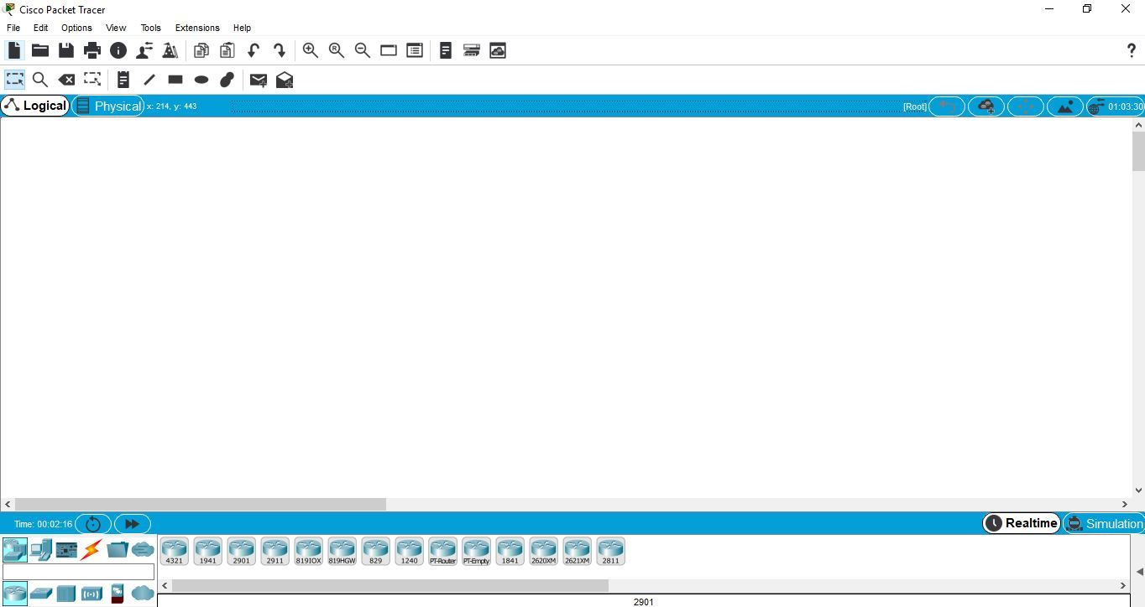

* Cisco IOS CLI

Most Cisco devices (including routers and switches) use a CLI (Command Line Interface) to configure the network device. The CLI is an interface, based on text. You type in configuration commands and use show commands to get the output from the router or switch. There are also GUIs (Graphical User Interface) for the routers, switches and firewalls but the majority of the work is done on the CLI. This might sound dated but with so many commands that are available to use, the CLI is much easier to work with than any of the graphical interfaces. It’s also much easier to copy entire configurations from one device to another. In this lesson, I’ll explain how to access the CLI and the basics of how Cisco IOS works.

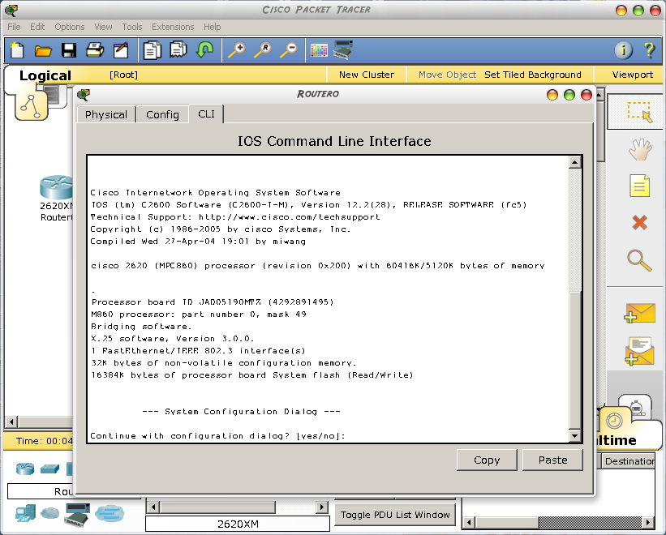Access to Cisco IOS CLI

* **Basic Switch Configuration & Device Security.**

1. The default router name is "Switch." Giving each switch a unique name aids in network management by allowing you to uniquely identify each switch within the network. The name of the switch is considered to be the host name and is displayed in the system prompt. Let's change the host name from "Switch" to "Switch1." Notice that the name in the system prompt changes immediately after the hostname command is entered.

|  |  |
| --- | --- |
| Task | Command |
| 1. From user EXEC mode, enter privileged EXEC mode. | enable |
| 2. From privileged EXEC mode, enter global configuration mode. | Configure Terminal |
| 3. From global configuration mode, configure a new host name. | hostname host_name |

1. **Exit , clock set 11:56:50 01 Dec 2018, show clock**

Set the Error! Hyperlink reference not valid. so that error messages will have accurate Error! Hyperlink reference not valid.. The router will use this information to timestamp error messages. Use the following information for the time and date: 11:56:50 01 March 2018. Then use the show clock command to view the new clock setting.

|  |  |
| --- | --- |
| Task | Command |
| 1. From global configuration mode, return to privileged EXEC mode. | exit |
| 2. From privileged EXEC mode, set the system clock. | clock set hh:mm:ss day month year |
| 3. From privileged EXEC mode, view the clock setting. | show clock |

1. **configure terminal, banner motd # Technology Department #, exit, <CR>**

The message-of-the-day banner is displayed at login and is useful for sending startup messages to all connected terminals. By default, no message is displayed at logon. Enter the banner motd command in global configuration mode. When using the banner motd command, enter a few blank spaces and then type a delimiting character. The information typed until the next delimiting character is recognized as the message of the day. In this simulation, use the pound key (**#**) as the delimiting character.

1. **enable, configure terminal, interface ethernet 0, description FirstEthernetInNetwork1, Ctrl-Z , show running-config**

Now display the running configuration, to see the interface description you just configured. To display the running configuration, use the show running-config command in privileged EXEC mode.

In a configuration display, the exclamation marks function as line separators to make reading easier. In this configuration, notice how commands entered at the interface configuration level, such as the interface description command, appear indented underneath the interface they were entered on. Global-level commands are not indented, so you can easily identify which configuration parameters are set at the global configuration level and which are set at the various configuration sublevels.

Notice the commands that you have configured so far in this Basic Configuration Lab: hostname, service timestamps, banner motd, and interface description.

|  |  |
| --- | --- |
| Task | Command |
| 1. From user EXEC mode, enter privileged EXEC mode. | enable |
| 2. From privileged EXEC mode, enter global configuration mode. | configure terminal |
| 3. From global configuration mode, enter interface configuration mode. | interface type number |
| 4. From interface configuration mode, configure an interface description. | description interface_description |
| 5. From interface configuration mode, return to privileged EXEC mode. | <Ctrl-Z> |
| 6. From privileged EXEC mode, display the running configuration. | show running-config |

1. **configure terminal, line console 0, password Cisco, Ctrl-Z, exit, <CR>, Cisco**:

You can use the password command, in line configuration mode, to configure a password to restrict access to a switch. Console passwords can be established on individual lines. Remember that passwords are case-sensitive. Passwords can be configured for console terminals or for incoming Telnet sessions. Configure the password Cisco for console line 0. Then exit the EXEC completely and log back into the switch. You will be prompted for the console password you just configured before you can enter user EXEC mode.

|  |  |  |  |
| --- | --- | --- | --- |
| |  |  | | --- | --- | | **Task** |  | | Command |
| 1. From privileged EXEC mode, enter global configuration mode. | configure terminal |
| 2. From global configuration mode, enter line configuration mode for a console line. | line console line_number |
| 3. From line configuration mode, configure a console password. | password password |
| 4. From line configuration mode, return to privileged EXEC mode. | <Ctrl-Z> |
| 5. From privileged EXEC mode, exit the EXEC entirely. | exit |
| 6. Press Return when prompted. | <CR> |
| 7. Enter the console password at the prompt, to enter user EXEC mode. | password |

1. **enable, configure terminal, line vty 0 4, password Cisco**

To further restrict access to the switch, configure the password Cisco for Error! Hyperlink reference not valid. Zero through four.

|  |  |
| --- | --- |
| Task | Command |
| 1. From user EXEC mode, enter privileged EXEC mode. | enable |
| 2. From Privileged EXEC mode, enter global configuration mode. | configure terminal |
| 3. From global configuration mode, enter line configuration mode for a virtual | line vty line_number [ending_line_number] |
| 1. From user EXEC mode, enter privileged EXEC mode. | enable |

1. **exit, enable password Cisco, exit, disable, enable, Cisco**

Use the enable password global configuration command to configure an enable password to restrict access to privileged EXEC mode. Use Cisco as the password. Then return to user EXEC mode and test the enable password by reentering privileged EXEC mode.

|  |  |
| --- | --- |
| Task | Command |
| 1. From line configuration mode, return to global configuration mode. | exit |
| 2. From global configuration mode, configure an enable password. | enable password password |
| 3. From global configuration mode, return to privileged EXEC mode. | exit |
| 4. From privileged EXEC mode, return to user EXEC mode. | disable |
| 5. From user EXEC mode, reenter privileged EXEC mode, entering the enable password when prompted. | enable  password |

1. **configure terminal, logging buffered**

To copy logging messages, such as errors, to an internal buffer, use the logging buffered command. The buffer is circular, so those newer messages overwrite older ones after the buffer is filled. Having a log of these messages can be useful when troubleshooting network problems. Now let's generate some logging messages.

|  |  |
| --- | --- |
| Task | Command |
| 1. From privileged EXEC mode, return to global configuration mode. | configure terminal |
| 2. From global configuration mode, configure the system to log messages to an internal buffer. | logging buffered |

**HOME ASSIGNMENT**

Q1: Briefly describe any four (4) network types.

Q2: What is Communication between a computer and a keyboard involves transmission?

# Q3: Which command will end configuration mode and returns to EXEC

Q4: Are Packet Tracer Still Available Version?